KPI

* What Is the total Customers the data have?

Select

count(distinct id) as Total_Customers

from user_data_dup;

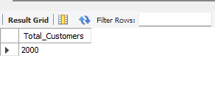

* How many unique credit cards does the data have?

Select

count(distinct num_credit_cards) as Total_Unique_Credit_cards

from user_data_dup;



* What is the most common gender in the dataset?

SELECT gender,

COUNT(*) AS gender_population

FROM user_data_dup

GROUP BY gender

ORDER BY gender_population DESC;



Business Key Problems and Answers

1. What is the average per capita income of users?

SELECT AVG(CAST(REPLACE(per_capita_income, '$', '') AS DECIMAL))

AS avg_per_capita_income

FROM user_data_dup;



1. What is the average total debt for users by gender?

SELECT gender, AVG(CAST(REPLACE(total_debt, '$', '') AS DECIMAL))

AS avg_total_debt

FROM user_data_dup

GROUP BY gender;



1. Which birth year has the most users?

SELECT birth_year, COUNT(*) AS total_users

FROM user_data_dup

GROUP BY birth_year

ORDER BY total_users DESC

LIMIT 1;

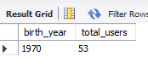

1. What is the average number of credit cards per user?

SELECT AVG(num_credit_cards) AS avg_credit_cards

FROM user_data_dup;



1. Which address has the highest per capita income?

SELECT address, MAX(CAST(REPLACE(per_capita_income, '$', '') AS DECIMAL))

AS max_per_capita_income

FROM user_data_dup

GROUP BY address

ORDER BY max_per_capita_income DESC

LIMIT 1;



1. What is the average credit score of users with more than 3 credit cards

SELECT AVG(credit_score) AS avg_credit_score

FROM user_data_dup

WHERE num_credit_cards > 3;

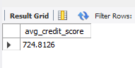

1. Which age group has the highest debt?

SELECT current_age, AVG(CAST(REPLACE(total_debt, '$', '') AS DECIMAL)) AS avg_debt

FROM user_data_dup

GROUP BY current_age

ORDER BY avg_debt DESC

LIMIT 1;



1. How many users have reached retirement age?

SELECT COUNT(*) AS retired_users

FROM user_data_dup

WHERE current_age >= retirement_age;

